## Small Groups – Understanding God's will, one day at a time? Date: _________________

*By Rev Richard Braun* Week _________________

### Icebreaker

Do you have any present or historical heroes that are good examples of people who followed God's will, one day at a time? Who & describe why they might be your hero?

### Opening Prayer

Heavenly Father, what is your will for us? We don't always recognize or follow what you have in mind. We search, struggle, and often fail because we are weak and don't even do what we know is right. Help us now; help us understand how we find your will in your Word, your people, and your Spirit. Please help us to listen and allow us to stay alert. In Jesus' name, we pray, Amen.

### Open It

1. What is one TV show you like to watch regularly? If you don't have one, how about a movie you've seen that you liked? Tell us about it.

2. Did you vote in a recent election? Was there a candidate or proposition about which you felt strongly? Did you vote for the candidate based on their faith or another criterion? Why?

3. What is one thing you will do this year during a holiday? Is this a family thing, a tradition, or something new you've never done? What purpose does it play or serve in your life?

4. Did you have a teacher who made a significant impression on you while growing up? Tell us about that person and the impact they had on you.

**Explore It**

1. In Exodus 2:2-7, Moses is placed in the river Nile in a basket in the tall grass. The result seems to speak to us about God's sovereign will. Looking back on your life thus far, what event has been similar, and how did it demonstrate God's sovereign will to you?

2. In Exodus 3:1-10, Moses receives a call from God. What do you believe this call tells us about how God calls people into service in his kingdom? What does it show? Is this relevant in our world today?

3. Exodus 3:11 & 12 shows us a typical response we have to God calling us. Have you ever responded to God in this way? If so, describe the circumstance.

4. Does an event like that described in #3 have anything to do with seeking God's will in our own lives? Is there a connection or relationship with what you know about seeking God's will?

### 

### Get It

1. If scripture explains one way to follow God, are there other ways to know God's will? What's one passage that indicates what it means to follow God's will in your life today? Here are some samples – I Thessalonians 5:12-18, Romans 8:29-30, I Timothy 2:3-4, Ephesians 5:15-18, Rom 8:9-15 List others.

2. We can all agree that listening to people is another way to hear God's call. Does this mean new or additional revelations will supersede our knowledge of God's will beyond what we now have in scripture? Why or why not? Matt 24:4 & 11-14. What does it indicate about God?

3. How do we know good spiritual input from lousy theology? What test do you use currently? Read Matthew 7:15-19 - then discuss how this test would work in a real-world situation.

4. What does it mean to say that God speaks through circumstances? Describe a personal event where you believe God spoke to you through the circumstances. Acts 16:6-10 or 16:26-28

5. God speaks through the Holy Spirit. This method of listening to God always seems like it's the most difficult for most of us to recognize or understand. It might be the Holy Spirit; then again, it just might be indigestion. How would you describe what it means to listen to the Holy Spirit? John 16:13

### Apply It

Let's see if we've learned anything about listening to God. Here is a common situation for most of us; how might you respond? State what you might do and how you would seek God's will.

You and your wife both have to work; you live in So. California, and you want the best for your kids. We all do; we want good schools, an excellent neighborhood, and a comfortable home. You're in your late 40s, and you're up for perhaps your last promotion for a good increase in salary is needed for the kids to go to college, but you know, at least two weeks/month, you'd need to travel. Obligations at church, in the community, and the family would need to lessen. Should you take the job? Tell the group how you would arrive at your decision.

God's wisdom decision-making model:

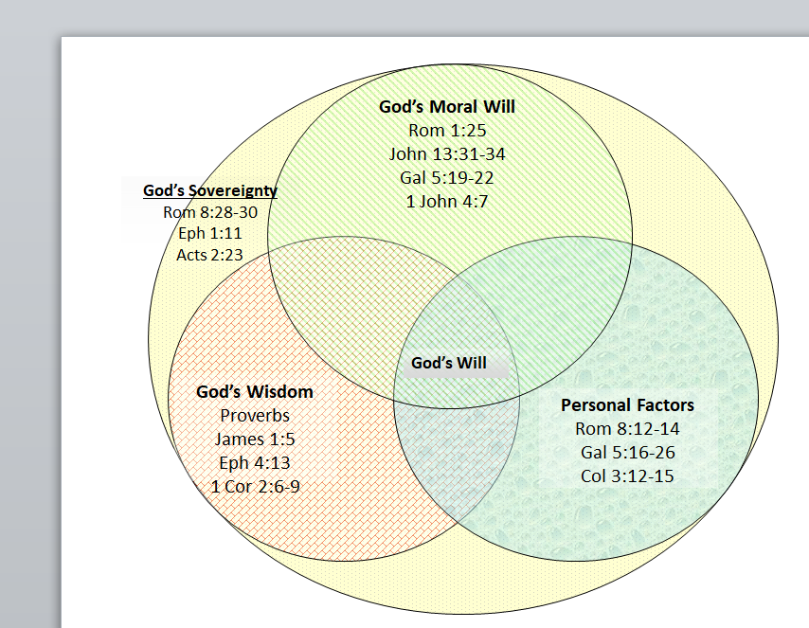

#### God’s Sovereign Will

2 Peter 3:9, 1 Thess 4:3, Eph 5:16-18, 1 Peter 2:13-15, 1 Thess 5:15-18, James 1:5, Prov 2:9

God's will for us deals with the factors that occur at the intersection of His moral will and His wisdom, which we can find in the Bible. His sovereign will overrides everything, of course. If we make decisions against His moral will or wisdom, we are not operating according to his will.

### Closing Prayer - Please ask about praise reports or issues needing prayer

## Lord God, we pray that we might search your Word and discover your will for our lives. We know nothing of your will without knowing you, your laws, and your grace. Please help us shape our lives around your Word today so we can follow your ways and wisdom in this world that's often confusing and stressful. Be with us now and forever, Amen.